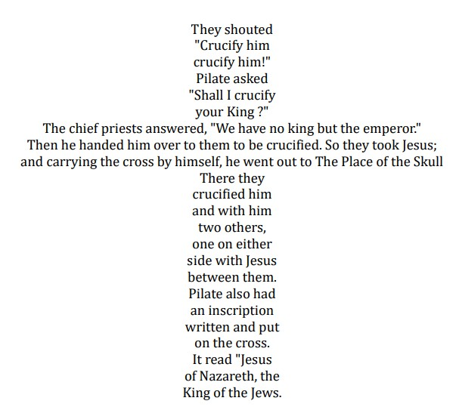
Service of Shadows and Stones
Good Friday
April 3, 2026 at 6:00 PM

Zion Lutheran Church 2982 Davis Road Fairbanks

